Metaphysics and Epistemology in Plato’s Academy
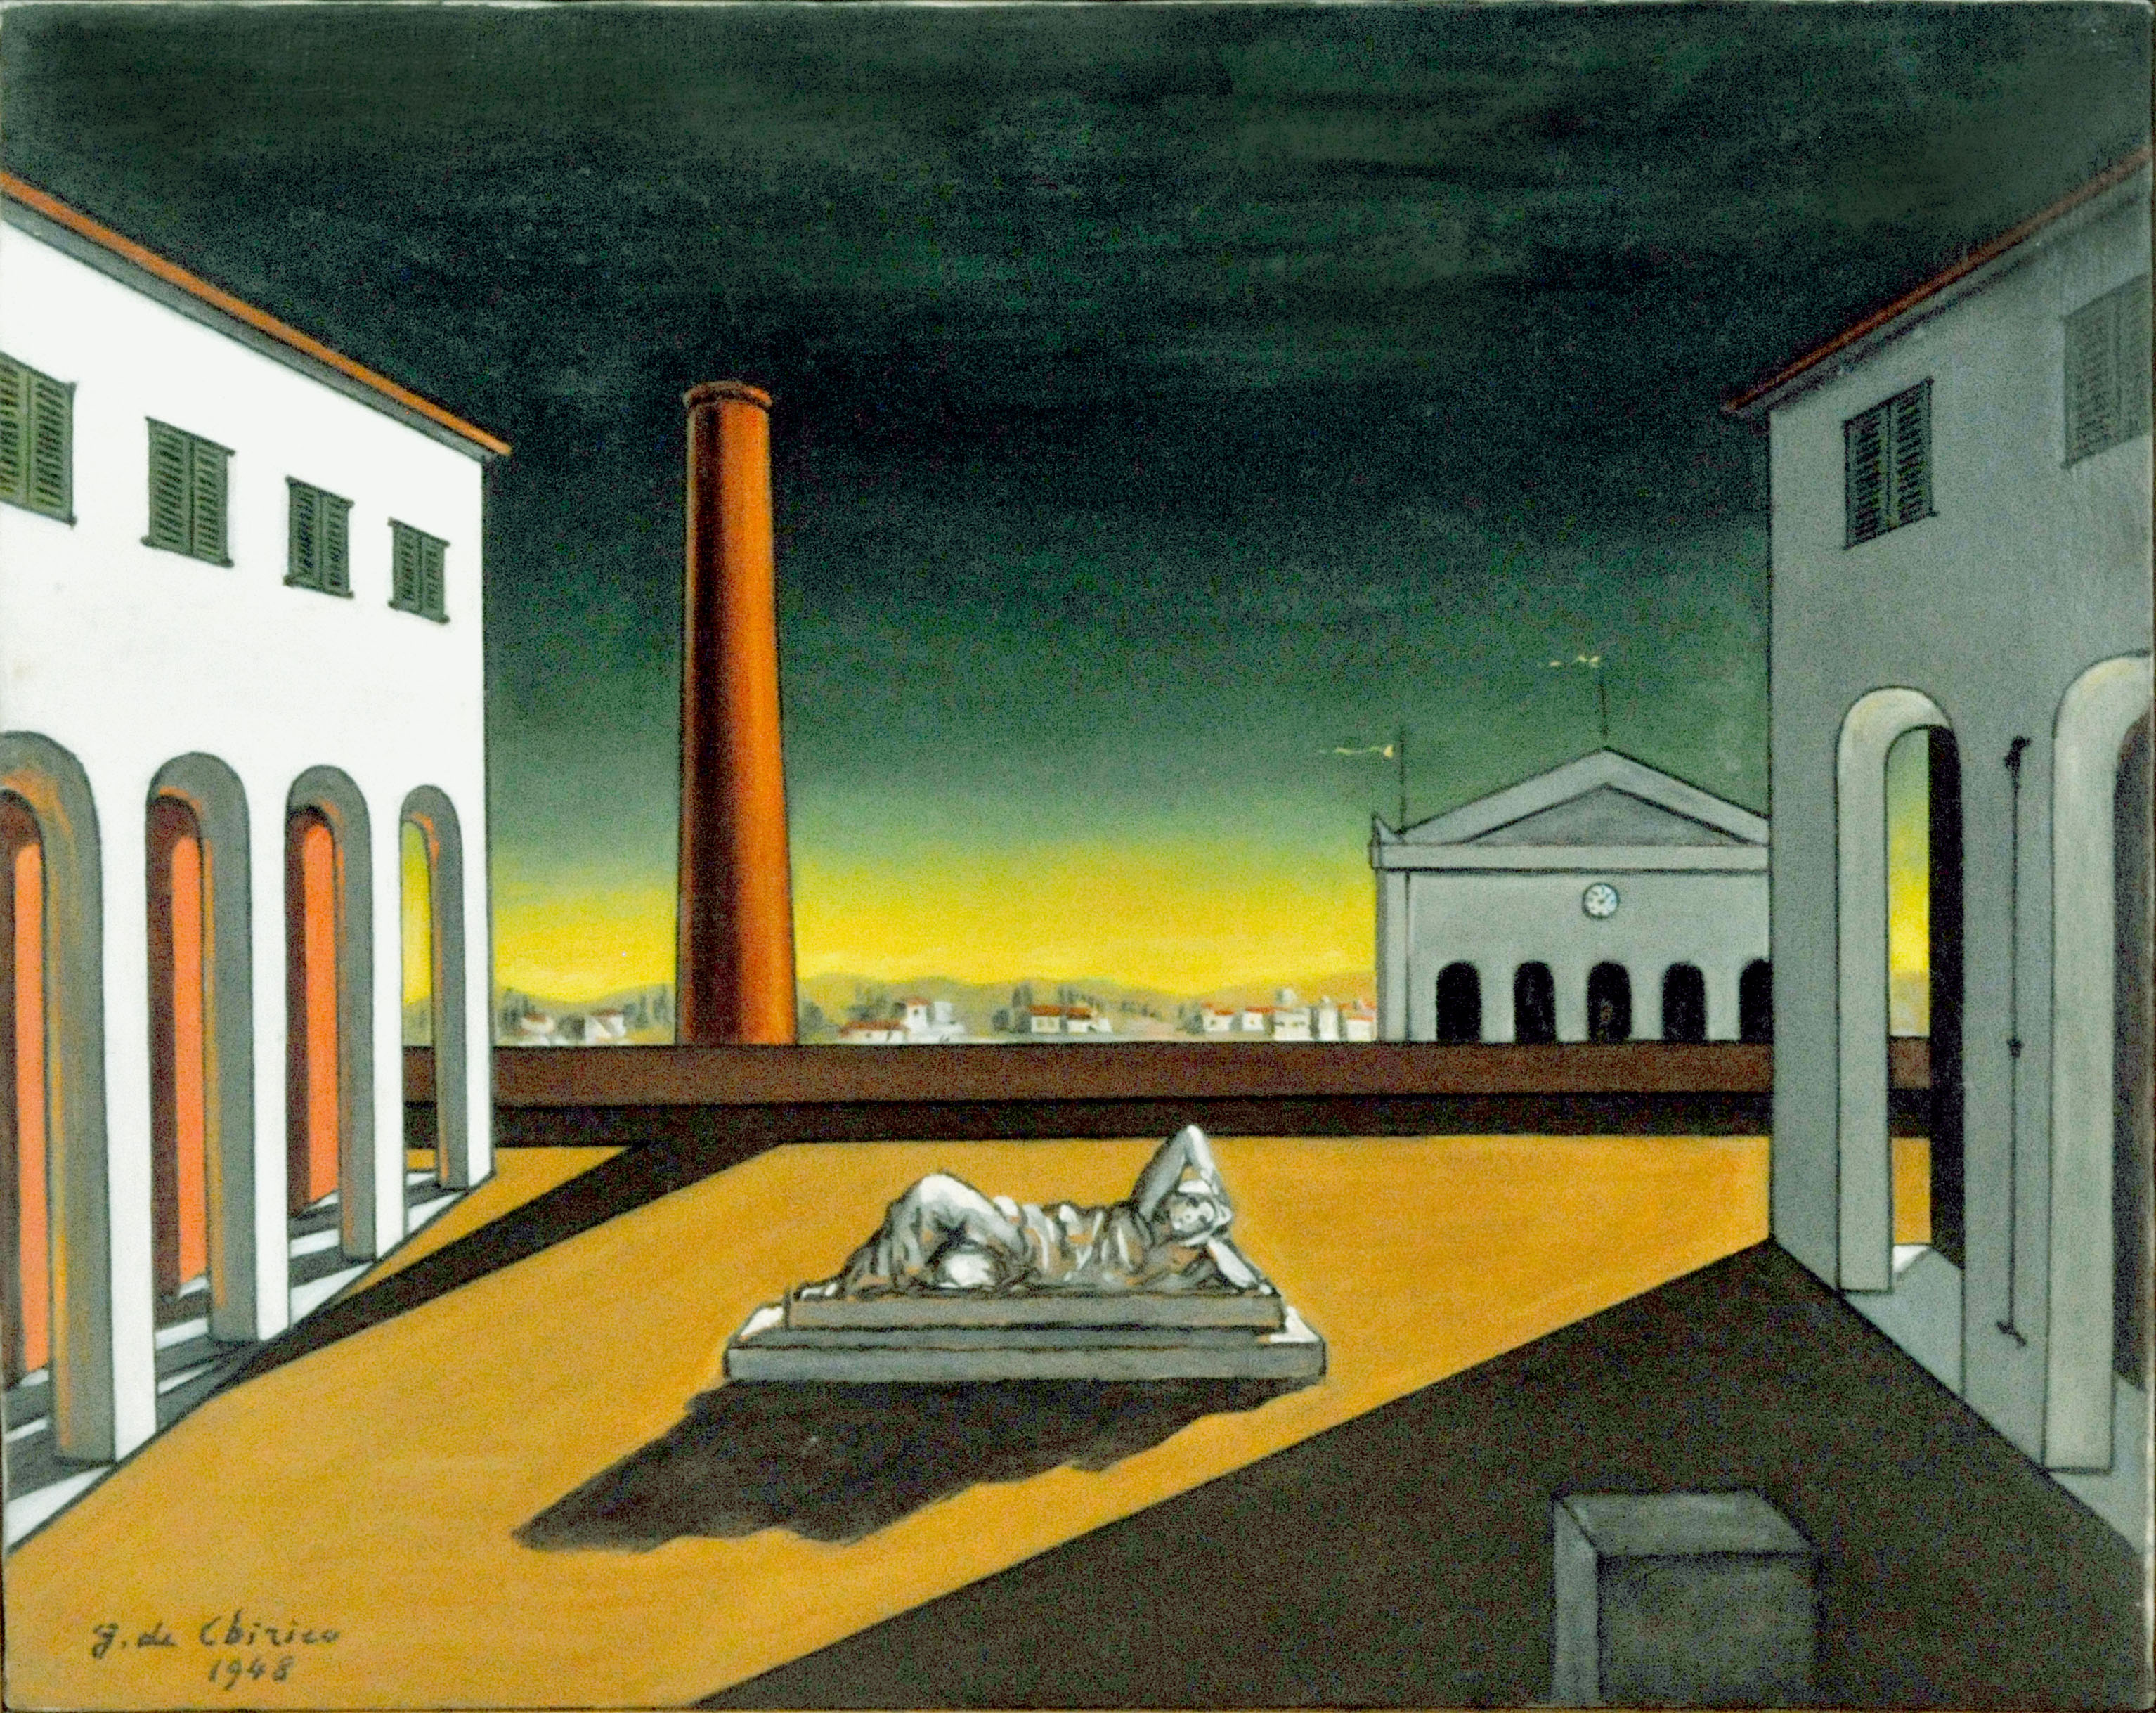

Organized by Carlo Cacciatori (Durham University), Giulia De Cesaris (Durham University) and Emilio Zucchetti (Newcastle University).

This workshop is made possible by support from the Faculty of Arts and Humanities and the Department of Classics and Ancient History at Durham University, and the Northern Bridge Doctoral Training Partnership. The workshop is free and open to the public, although registration is requested.

Through the generosity of Northern Bridge Doctoral Training Partnership, we are able to offer small bursaries to support postgraduates and early career scholars who would like to participate in the workshop. Applicants are required to send (to the email addresses below) a brief description (max. 150 words) of why they are interested in taking part in the workshop and how their research relates to the topic of the workshop.

The deadline for submitting applications for these bursaries is Friday 12 January 2018. On Sunday 14 January 2018 we will communicate the outcome of the applications.

To register for the workshop or to attend the dinner on Thursday night, please contact Carlo Cacciatori (carlo.cacciatori@durham.ac.uk) or Giulia De Cesaris (giulia.de-cesaris@durham.ac.uk) no later than Friday 16 February 2018. More information about dinner will be available closer to the conference date.

Please note that the workshop is meant to coincide with the visits of Lloyd Gerson (Toronto) and David Sedley (Cambridge) to the newly-launched Durham Centre for

Ancient and Medieval Philosophy on, respectively, 20 and 22 February (for more information, see http://www.dcamp.uk/calendar/).

Description of the workshop:
This workshop will investigate the relationships between metaphysics and epistemology as they were interwoven within Plato’s Academy. It seeks to understand the co-implication of the theories of being and knowledge as they are expressed in the dialogue between Plato’s later thought and that of his younger contemporaries (Eudoxus, Aristotle, Speusippus, Xenocrates, Philip of Opus, and Heraclides of Pontus) in the Academy.

Speakers:
Thomas Bénatouïl (Lille); Laura Castelli (Munich); Filippo Forcignanò (Milan); Roberto Granieri (Toronto); Victor Gysembergh (Berlin); David Sedley (Cambridge); Georgia Tsouni (Bern).
Chairs of sessions:
George Boys-Stones (Durham); Tiziano Dorandi (Paris); Lloyd Gerson (Toronto); Nathan Gilbert (Durham); Phillip Horky (Durham); Federico Petrucci (Durham); Christopher Rowe (TBC, Durham).

Date and venue:
February 21st-22nd (2018), Horsfall room, Ramsey House, 25 North Bailey, DH1 3EW. This event will take place in one of the oldest colleges in Durham, St Chad’s. It is situated within a stone’s throw from Durham Cathedral – a World Heritage Site – and we will be hosted in one of the Georgian town houses which St’ Chad’s occupies along the North Bailey.

Programme of the workshop

21.02.18
09.00-09.30 Reception and coffee

09.30-09.40 Opening Remarks

09.40-10.40 Thomas Bénatouïl (Lille)
Speusippus between metaphysics and epistemology

10.40-11.40 Filippo Forcignanò (Milan)
Mixing Anaxagoras and Plato in the Old Academy: Eudoxus' immanentism and the Theory of Forms

11.40-12.00 Coffee Break

12.00-13.00 Laura Castelli (Munich)
The incompatibility between Forms and Principles in Aristotle’s περὶ ἰδεῶν

13.00 Lunch

14.30-15.30 Roberto Granieri (Toronto)
The Divisio Aristotelea 67M/32DL and the Debate on the Two Categories in the Early Academy'

15.30-16.00 Coffee Break

16.00-17.00 David Sedley (Cambridge)
Xenocrates and the invention of Platonism

20.00 Dinner

22.02.18
09.30-10.00 Coffee

10.00-11.00 Georgia Tsouni (Bern)
TBA

11.00-11.15 Coffee Break

11.15-12.15 Victor Gysenbergh (Berlin)
Eudoxus of Cnidus and Plato’s Academy

12.15-12.25 Closing Remarks

More information on the workshop will be available on http://www.dcamp.uk/events/metaphysics-epistemology-platos-academy/.

If you have any further questions about the workshop, please, do not hesitate to contact Carlo Cacciatori (carlo.cacciatori@durham.ac.uk) or Giulia De Cesaris (giulia.de-cesaris@durham.ac.uk).

Carlo Cacciatori (Durham University)
Giulia De Cesaris (Durham University)
Emilio Zucchetti (Newcastle University)

